DATE: **March 15th, 2021**

TO: **Dr. Deirdre Hunter**

FROM: **Sindhuja Darisipudi, Nora Han, Joseph Urso, Michael Tang, Jason Ye[1]**

**Team Moonrats (**[**5moonrats@gmail.com**](mailto:5moonrats@gmail.com)**)**

SUBJECT: **Water Assessment Incubator Final Design**

**Final Design for Water Assessment Incubator**

As our group worked through our design matrices, we realized that most of our highest scoring solutions had many elements in common (as identified through our Pugh Scoring Matrix). Since our design is extremely modular, we decided that it would be best to combine the best elements from each of our top designs to form the final design that we plan to move forward with into the prototyping phase. In brief, our final design is a thermos with heat tape along the inside into which we place a shelf of petrifilms. The thermos will be used as the main source of insulation, the heat tape for heating, and the shelf to hold the petrifilms in place. Figure 1 below shows a CAD design of the final design, including its dimensions. It should be noted that the final design is not see-through, but the CAD design is see-through in order to see the elements inside of the container. Figure 2 shows the expanded view of the design and breaks down the design into its components.

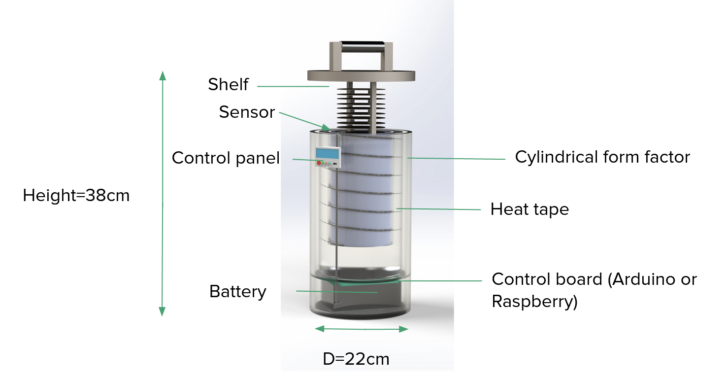

***Figure 1: CAD Design of Final Solution for Water Assessment Incubator***

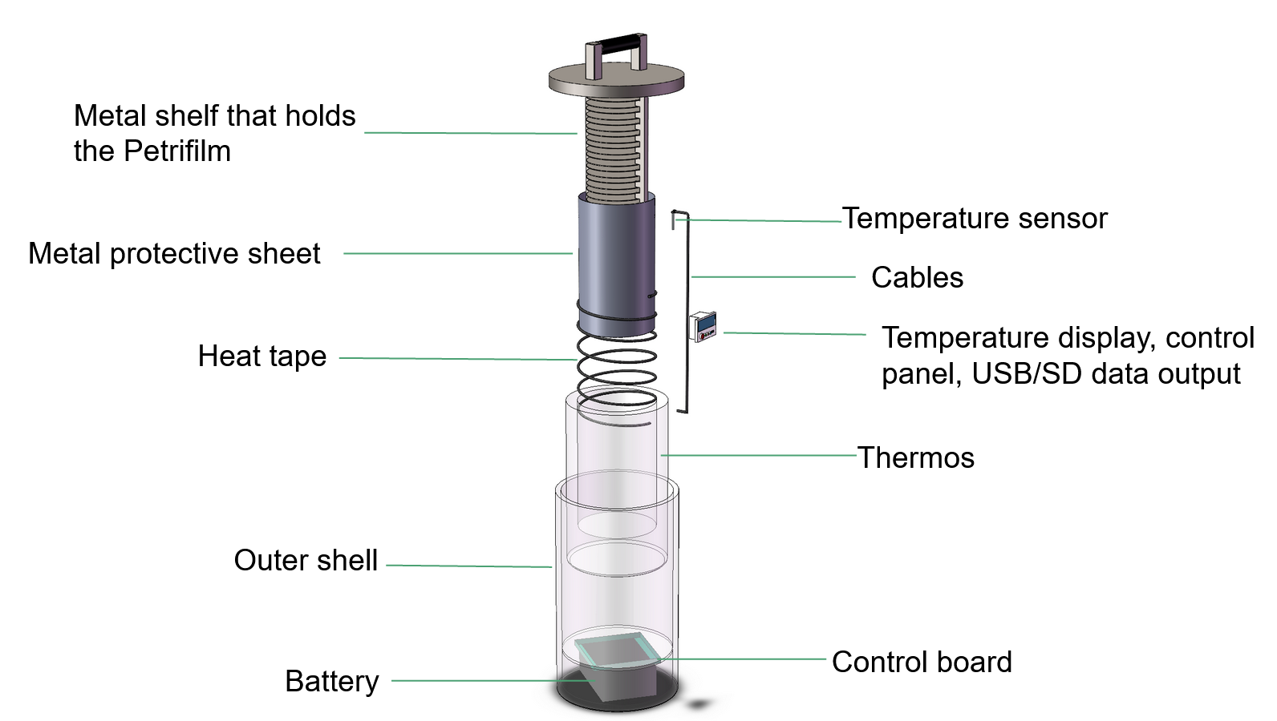

***Figure 2: Expanded CAD design of Water Assessment Incubator***

**Final Water Assessment Incubator Components**

Below is a list of the components of the final design and details about them including their respective functions, importances, and connections to design criteria.

1. Metal Shelf that Holds the Petrifilms
   1. **Function**: Holds petrifilms in place during incubation and during travel
   2. **Importance**: Allows for more heat to be transferred through conduction. Also keeps everything organized and in place during travel/incubation
   3. **Design criteria**: Helps with heating
   4. **Specifications**: Twenty shelves, each 0.5cm apart. Diameter of 18 cm; will be attached to the lid, which will be screwed into the outer shell
2. Metal Protective Sheet
   1. **Function**: Creates another level of security around the metal shelf and allows for more heat to transfer through conduction
   2. **Importance**: Allows for more heat to be transferred through conduction. Keeps Petrifilms protected during travel
   3. **Design criteria**: Assists with heating and durability
   4. **Specifications**: Twenty shelves, each 0.5cm apart; diameter of 18.5cm; will be screwed to the bottom
3. Heat Tape
   1. **Function:** Heats the incubator whenever the internal temperature drops below the specified temperature
   2. **Importance**: Creates the heat necessary for incubation
   3. **Design criteria**: Allows heating to occur in the incubator
   4. **Specifications**: 1 meter of heat tape wrapped around the metal protective sheet. Will be put in place using cable clips
4. Temperature Sensors
   1. **Function**: Monitors internal temperature for data logging and to trigger the heat tape to produce/stop producing heat
   2. **Importance**: Allows for temperature regulation inside of the incubator
   3. **Design criteria**: Allows for temperature regulation, meets desired specificity
   4. **Specifications**: 4 temperature sensors total (one at top & bottom of shelving, and one on the left & right walls at the center); will be epoxied in place
5. Cables
   1. **Function**: Link the microcontroller, battery, temperature sensor, and heat tape
   2. **Importance**: Allows for temperature regulation, heating, and data logging to happen (allows for the communication & power of all parts)
   3. **Design criteria**: Allows for all design criteria to be successfully met (not possible without functioning electronics)
   4. **Specifications**: Cables will link microcontroller to battery, microcontroller to temperature sensor, and heat tape to battery; attached with cable clips
6. Temperature Display
   1. **Function**: Displays the live temperature inside of the incubator
   2. **Importance**: Allows for detection of errors and communicates data to user
   3. **Design criteria**: Data logging/communication
   4. **Specifications**: OLED screen that displaces the temperature inside of the incubator (updated every 3-4 minutes); will be screwed in place
7. Thermos
   1. **Function**: Main insulation method
   2. **Importance**: Allows for the maintenance of temperature inside of the thermos without having to use battery power to constantly heat
   3. **Design criteria**: Heating/temperature regulation
   4. **Specifications**: Using a ~15x20cm thermos; will be attached with velcro to the bottom (in order to be easily removable)
8. Outer shell
   1. **Function**: Container for all components
   2. **Importance**: Allows for everything to be put together and be durable
   3. **Design criteria**: Durability
   4. **Specifications**: 22cm x 38 cm
9. Battery
   1. **Function**: Powers microcontroller, temperature sensor, and heat tape
   2. **Importance**: Allows for all electronics, and essentially the entire incubator, to function
   3. **Design criteria**: Battery life
   4. **Specifications**: Using a 12V/11000mAh battery; will be encased in foam and velcroed to the bottom
10. Microcontroller
    1. **Function**: Logs data from temperature sensor and controls internal temperature
    2. **Importance**: Allows for safe temperatures to be maintained inside of the incubator and logs data
    3. **Design criteria**: Data logging, temperature monitoring
    4. **Specifications**: Will be using Arduino nano; will be encased in foam and velcroed to the bottom

Elements that are not not illustrated above but will be in our final design are cable clips and foam. Details about those are listed below.

1. Cable Clips
   1. **Function**: Holds heat tape and other cables in place
   2. **Importance**: Allows for even temperature maintenance and durability
   3. **Design criteria**: Heating, durability
   4. **Specifications**: Will be located on the inside walls of the thermos and inside of the outer shell. There will be two for each loop that the heat tape makes around the thermos and one for every other cable in the device. Will be epoxied
2. Foam
   1. **Function**: Separates the electronics from the main incubation in order to prevent overheating
   2. **Importance**: Allows for electronics to work longer and more accurately
   3. **Design criteria**: Durability
   4. **Specifications**: Will encase the electronics by ~0.5 cm

We will also have to program on the microcontroller in order to link the microcontroller, heat tape, temperature sensor, and digital display. A schematic about the program that we will use can be seen in Figure 3 below

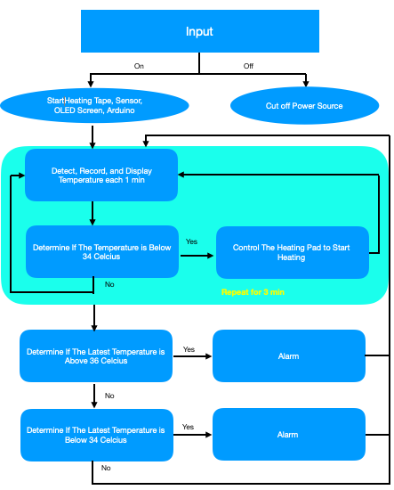

***Figure 3: Draft Flowchart For Medium Fidelity Prototype***

**Conclusion**

The cylindrical shape and the specially designed shelf impacted the selection of our materials. The cylindrical shape is important to our design because we are using vacuum insulation and the most common, cost efficient, and portable insulation device that applies vacuum insulation technology. Considering the degree of difficulty during the production of this device, we decided to modify or base our design on a thermos. This shape led to us using toilet paper rolls during low fidelity prototyping. In medium fidelity prototype, we might consider PVC transparent plastic sheets for our shells for more objective demonstration of inner structures. This shape formed our decision to use a thermos during high fidelity prototyping.

The specially designed shelf and sensor/battery holders would require 3D printers, thus we would be using CAD/Solidworks to draw 3D graphs for the prototype and try to assemble it with cardboards, and/or PVC transparent plastic sheets, and/or iron wires. In our medium/high fidelity prototypes, we plan to use laser-cut wood boards to get more precise parts of our selected solution.

The shelf and sensor/battery holders, along with our digital display will likely present the biggest challenge during prototyping. The coding will also present a challenge, as it requires multiple loops while we try to complete the coding for the temperature adjustment function. We will try to break down all of our components and turn it into a program that can run on an Arduino/Raspberry Pi board.

One salient process decision that we made was when selecting the type of battery that we use. We decided to calculate the energy efficiency of different batteries and heating tapes in an actual thermos. This allowed us to make decisions regarding how expensive of a battery we invest in in exchange for more power or a longer battery life.

Some memorable moments or discussions that led to breakthroughs was when we came up with different ways to arrange the components of the incubator during our discussions on the limiting temperatures and the size of our selected solution and the convenience of repairing and changing batteries. Our email discussions with our client confirmed that we could include 3D printed parts in our final design. Last, as we were forming our final design, we decided that it would be best if we purchased multiple heating parts and insulation types in order to give ourselves more flexibility.

1. Main Writers: Sindhuja Darisipudi and Nora Han